**Overview**

Outlook Mobile is an app that brings your email account to your iOS/Android mobile device, and also lets you conveniently access your Box account, keeping all your contacts and files are in the same place. Through your Box account, you can pull/attach files quickly and easily.

**Set-Up and Configuration**

Download the Outlook Mobile app from the iTunes Apple Store or the Google Play Store. After downloading, click **Install**.

* 1. Open the Outlook Mobile app.
  2. Click on Get Started. (Pictured below left)
  3. Select Office 365.

1. Type in your email address only.
2. Type in your username and password at the red CAA page.
   1. Once your email has been activated, you can click **Settings** to add another account, such as Box, Gmail, One Drive, etc. Here's how to set up your Box account:
   * Select Box to link your Box account.
   * Type in your email account only. Make sure you click **Single Sign On** at the bottom.
   * Click **Authorize** when asked, and you'll have access to your Box account from within the Outlook mobile app. (Pictured below right)

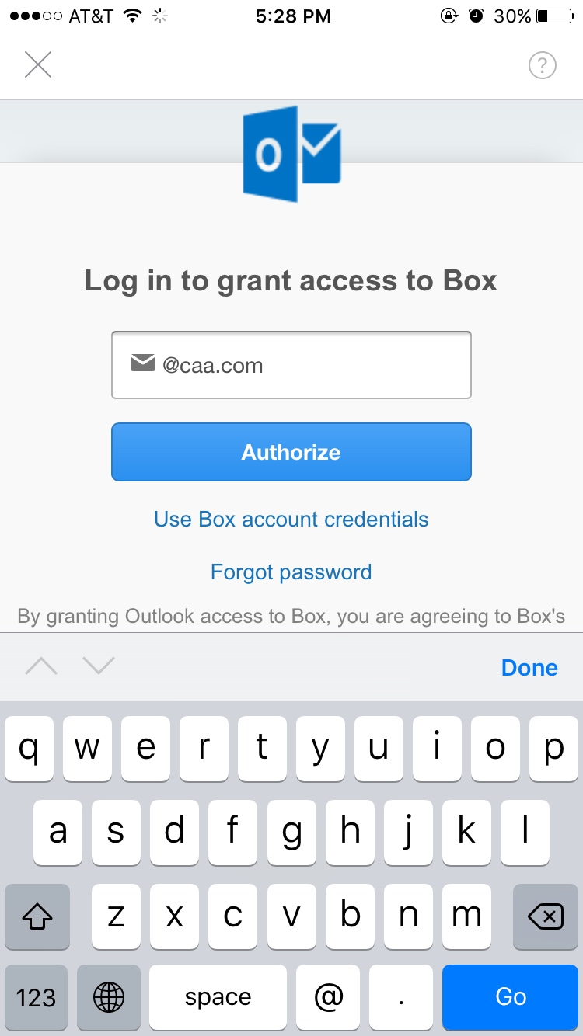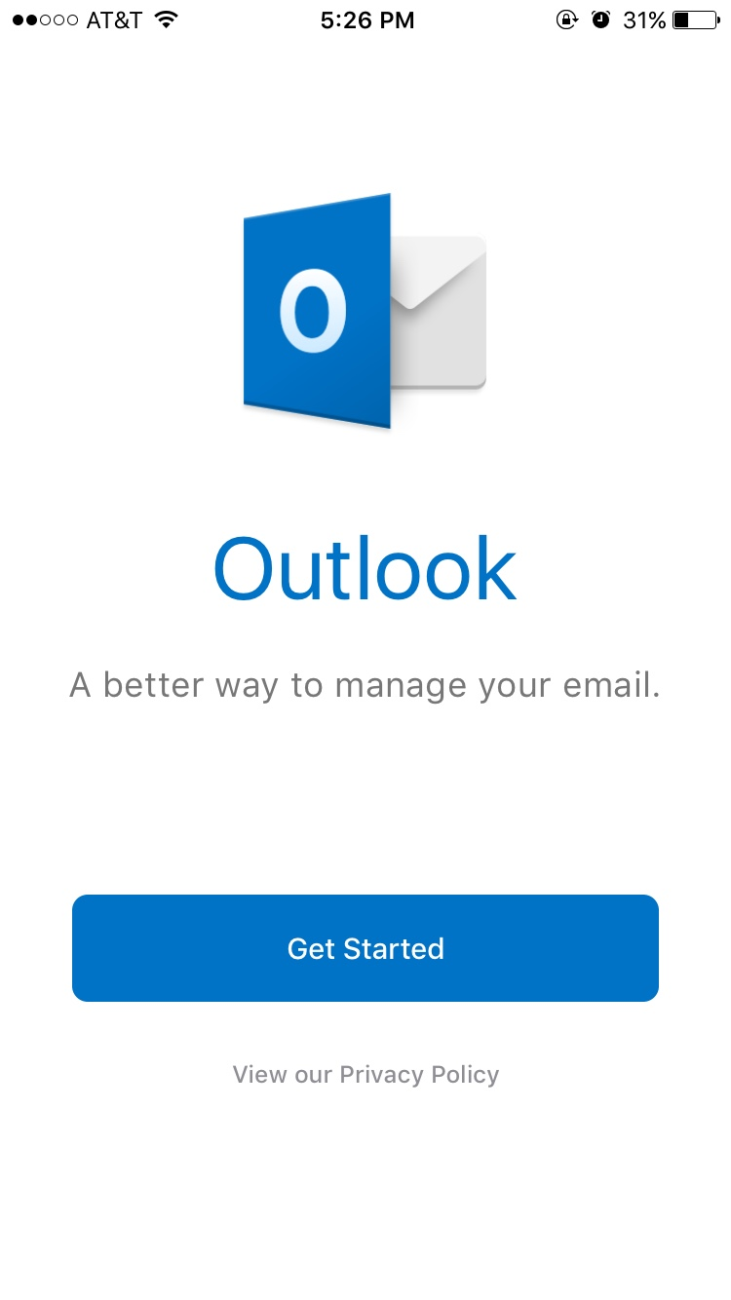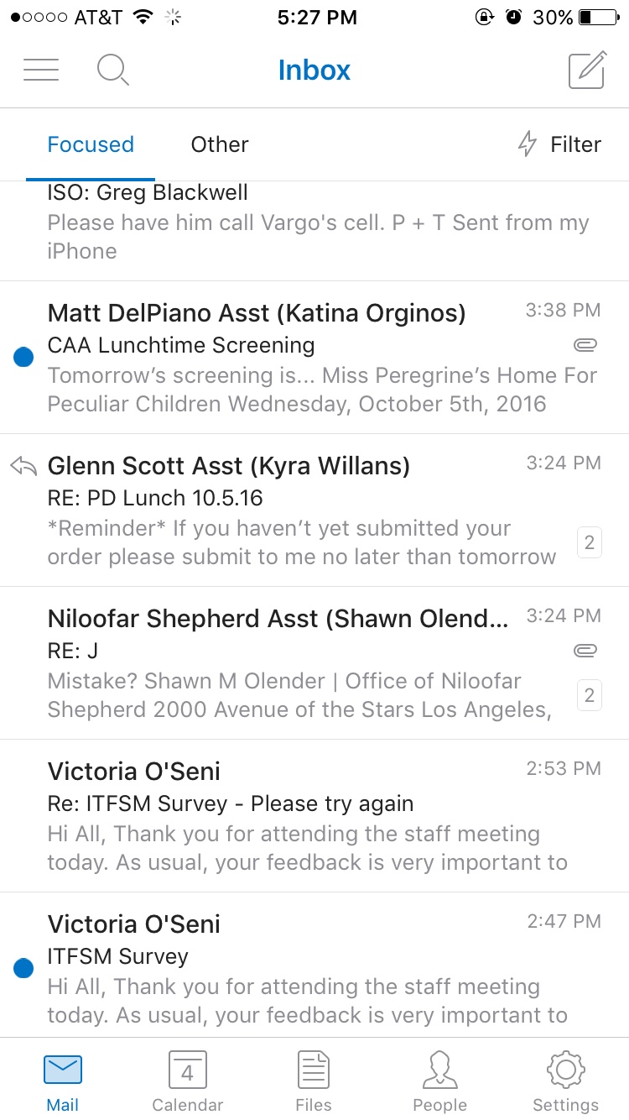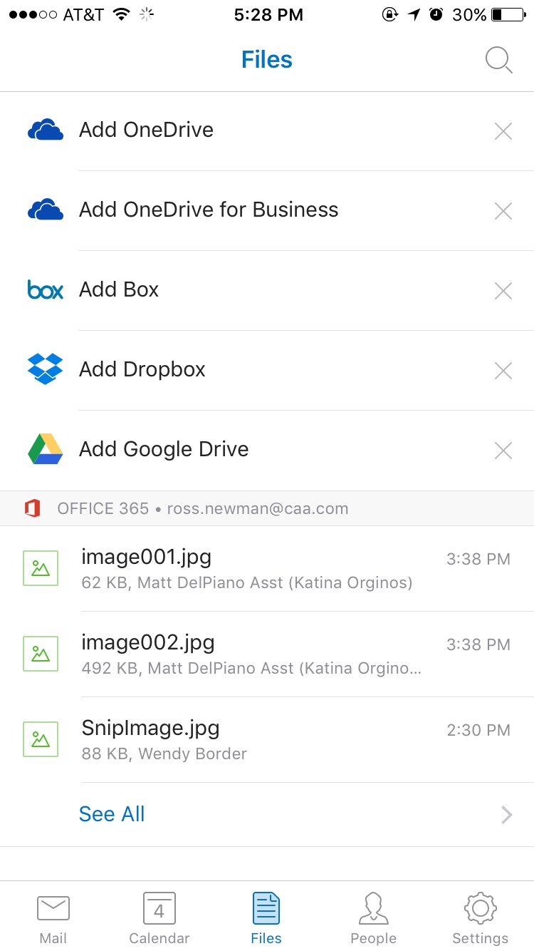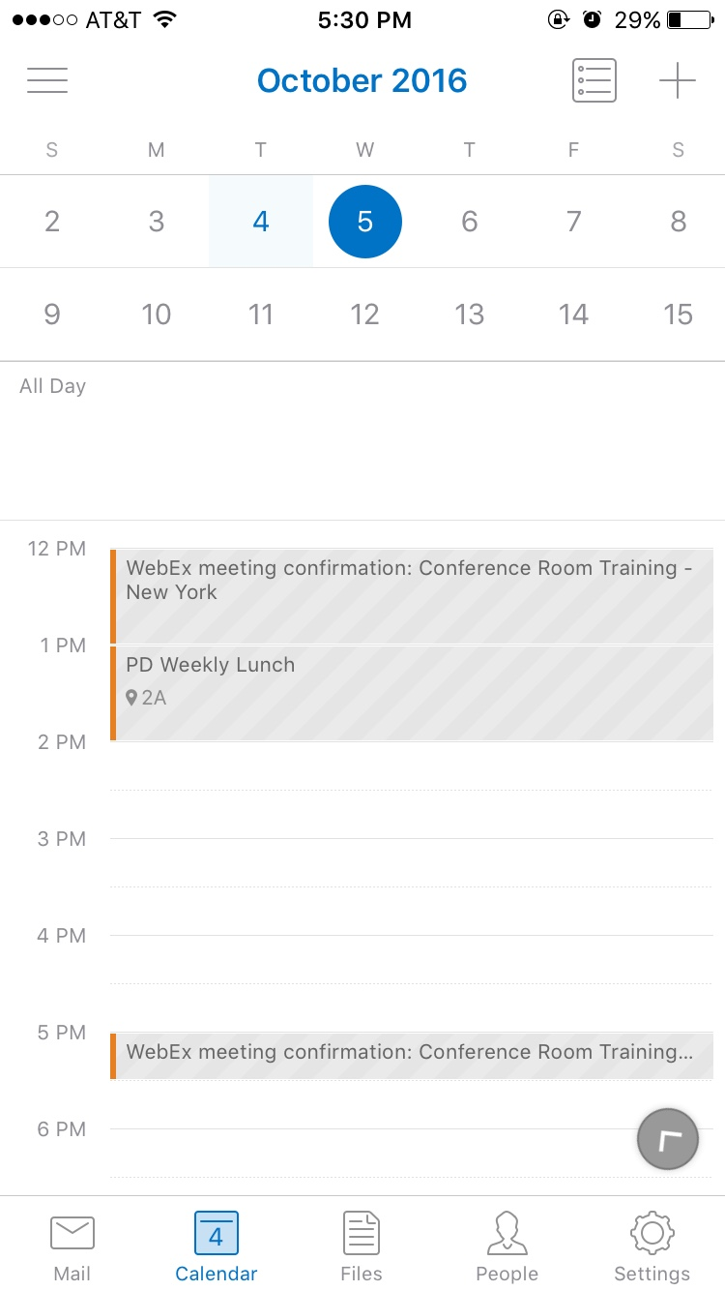

Managing your email and files is simple. Multiple accounts from email and cloud services will all now sit in the same place. Outlook also features an extensive built-in calendar.

**FAQs**

* **Which platforms is Outlook Mobile available on?**

Outlook Mobile is available as a mobile app for any Android or IOS device.

* **What accounts will I need to set up?**

You'll definitely need your CAA email account. You'll also need to first set up a Box account. Then, this app lets you connect them together.